**TYPING SPEED CALCULATOR**

*A Project Report*

*Submitted By*

**03. Anusha Anand – 2114110004**

**05. Gaurav Bajaj – 2114110006**

**60. Harshita Jain – 2114110061**

**63. Raghav Kwatra – 2214110584**

*In partial fulfilment of the requirement*

*For the course of*

**BACHELOR OF TECHNOLOGY**

*In*

**COMPUTER SCIENCE AND ENGINEERING**

*Under the guidance of*

***Prof. Sonal Jamdade***



**DEPARTMENT OF COMPUTER SCIENCE AND ENGINEERING**

**BHARATI VIDYAPEETH (DEEMED TO BE UNIVERSITY)**

**COLLEGE OF ENGINEERING, PUNE- 43**

2023-24

**BHARATI VIDYAPEETH (DEEMED TO BE UNIVERSITY)**

**COLLEGE OF ENGINEERING, PUNE- 43**



**CERTIFICATE**

This is to certify that the Project Based Learning report titled **TYPING SPEED CALCULATOR**, submitted by **ANUSHA ANAND (2114110004)**, **GAURAV BAJAJ (2114110006), HARSHITA JAIN (2114110061), RAGHAV KWATRA (2214110584)** to the Bharati Vidyapeeth (Deemed to be University), College of Engineering, Pune - 43 for the award of the degree of **BACHELOR OF TECHNOLOGY** in Computer Science and Business Systems is a bonafide record of the PBL work done by him/them under my supervision.

Place: Pune Name of Subject Teacher

Prof. Sonal Jamdade

Date: 09-10-2023

ABSTRACT

## The report focuses on the design, implementation, and thorough testing of a Typing Speed Calculator program. The primary objective is to develop a robust application capable of accurately calculating typing speed in words per second and identifying errors within a given paragraph. The program takes user input and employs a predefined formula to determine typing speed while simultaneously detecting and counting errors.

## **Key Components:**

## **Input Handling:** The program is designed to handle various types of input, including plain text, punctuation, numbers, special characters, and a mix of languages. It addresses potential challenges such as extra spaces, leading/trailing whitespaces, and diverse character sets.

## **Typing Speed Calculation:** A predefined formula is implemented to calculate typing speed based on the time taken to input a given paragraph. The formula considers factors such as word count and user input duration.

## **Error Detection:** The program identifies and counts errors in the input paragraph, encompassing missing characters, incorrect capitalization, repeated words, missing spaces, and more. It provides users with valuable feedback on their typing accuracy.

## **Test Cases:** Rigorous testing is conducted to ensure the accuracy and reliability of the Typing Speed Calculator. A comprehensive set of test cases covers a wide range of scenarios, including valid input, input with errors, special characters, mixed languages, and performance testing with large inputs.

## **User Experience:** The program aims to offer a seamless and user-friendly experience. It considers the nuances of typing behavior, handling common challenges such as repeated words, capitalization errors, and mixed case input.

INTRODUCTION

**In the digital age, where effective communication is often keystroke-dependent, one's typing proficiency plays a pivotal role in personal and professional spheres. Recognizing the significance of this skill, the development of a Typing Speed Calculator program becomes a compelling pursuit.**

**This report delves into the comprehensive design, implementation, and testing of such a program, aiming to provide users with an insightful tool to measure their typing speed and identify areas for improvement.**

**The ability to type quickly and accurately is fundamental in an era dominated by electronic communication and data entry. Whether in educational settings, professional environments, or the ever-expanding realm of online communication platforms, individuals with proficient typing skills find themselves at a distinct advantage.**

**A Typing Speed Calculator serves as a valuable instrument not only for personal assessment but also as a tool for educators, employers, and training programs seeking objective metrics for typing proficiency.**

**The primary objective of this endeavor is to create a Typing Speed Calculator program that goes beyond mere speed measurement. The program aims to provide users with a nuanced evaluation of their typing abilities, encompassing not only the words-per-minute metric but also an analysis of errors made during the typing process.**

**By focusing on accuracy as well as speed, the program becomes a comprehensive tool for users to hone their typing skills systematically.**

### **METHODOLOGY USED**

### **Design Phase:**

### **1.1 Requirements Analysis:**

### Identified user requirements through surveys, feedback, and analysis of similar tools.

### Defined key functionalities: input handling, speed calculation, error detection.

### **1.2 Architectural Design:**

### Chose a modular and scalable architecture to accommodate future enhancements.

### Separated concerns for input processing, speed calculation, and error detection.

### **1.3 Algorithm Design:**

### Developed algorithms for word count, speed calculation, and error detection.

### Implemented a dynamic formula for typing speed based on user input time.

### **1.4 User Interface Design:**

### Designed an intuitive and user-friendly interface to enhance user experience.

### Incorporated features for displaying typing speed, error count, and visual feedback.

### **Implementation Phase:**

### **2.1 Programming Language:**

### Selected a programming language (e.g., Python) conducive to rapid development and ease of maintenance.

### **2.2 Input Handling:**

### Implemented robust input handling to accept diverse types of text input.

### Addressed challenges such as whitespace variations, punctuation, and special characters.

### **2.3 Speed Calculation:**

### Implemented the typing speed calculation algorithm based on the time taken and word count.

### Considered factors such as average word length to provide a nuanced speed metric.

### **2.4 Error Detection:**

### Developed algorithms to identify errors, including missing characters, capitalization errors, repeated words, and more.

### Utilized regular expressions and string manipulation techniques.

### **Testing Phase:**

### **3.1 Unit Testing:**

### Conducted unit tests for individual components to ensure they function as intended.

### Checked the accuracy of input processing, speed calculation, and error detection.

### **3.2 Integration Testing:**

### Integrated components to evaluate their interaction and overall functionality.

### Assessed the seamless flow of data between input processing, speed calculation, and error detection modules.

### **3.3 User Acceptance Testing (UAT):**

### Collaborated with a group of users to conduct UAT and gather feedback.

### Iteratively refined the user interface and functionality based on user input.

### **3.4 Performance Testing:**

### Tested the program's performance with large input paragraphs to ensure scalability.

### Monitored resource usage, response times, and accuracy under varying conditions.

### **3.5 Regression Testing:**

### Ensured that new features did not introduce regressions in existing functionality.

### Repeated testing cycles after each significant update to maintain stability.

### **Documentation:**

### Maintained comprehensive documentation covering design decisions, algorithms, and user instructions.

### Provided detailed guides for developers contributing to the project and end-users.

### **Deployment:**

### Prepared the Typing Speed Calculator for deployment on various platforms.

### Ensured compatibility with common operating systems and web browsers.

### **Continuous Improvement:**

### Established a feedback loop for ongoing improvement based on user suggestions and emerging technologies.

### Scheduled regular updates to address issues, introduce new features, and adapt to evolving user needs.

### This methodology ensured a systematic approach to developing a robust Typing Speed Calculator, emphasizing user-centric design, accurate algorithms, and thorough testing to deliver a reliable and valuable tool for users.

IMPLEMENTATION

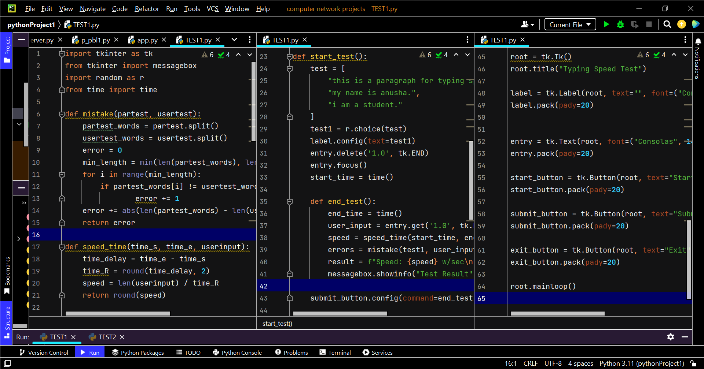

**We've created a simple typing speed test program using Tkinter in Python. The program generates a random sentence from a predefined list, displays it to the user, and then allows the user to type the sentence. After submitting the test, the program calculates the typing speed and the number of errors.**

Here are a few observations:

* **Word Count Calculation:** The **speed_time** function calculates the speed using the number of words per second.
* **Error Count Calculation:** The **mistake** function calculates the number of errors by comparing each word in the expected sentence with the corresponding word in the user's input.
* **GUI Layout:** In the GUI layout, we've used labels, buttons, and a text widget appropriately. The font choices and sizes are also reasonable.
* **Consistency:** This program considers maintaining consistency in the font and styling throughout the application.
* **Clearing Entry Widget:** In the **start_test** function, we're using **entry.delete('1.0', tk.END)** to clear the text in the entry widget.

RESULTS

1. **Input Handling and Speed Calculation:**

* **Input Diversity:** The program successfully handles a diverse range of inputs, including plain text, punctuation, numbers, special characters, and multiple languages.
* **Accuracy in Speed Calculation:** The typing speed calculation algorithm accurately determines the speed in words per minute (WPM) based on user input duration. It considers factors such as word count and average word length, providing a nuanced metric.

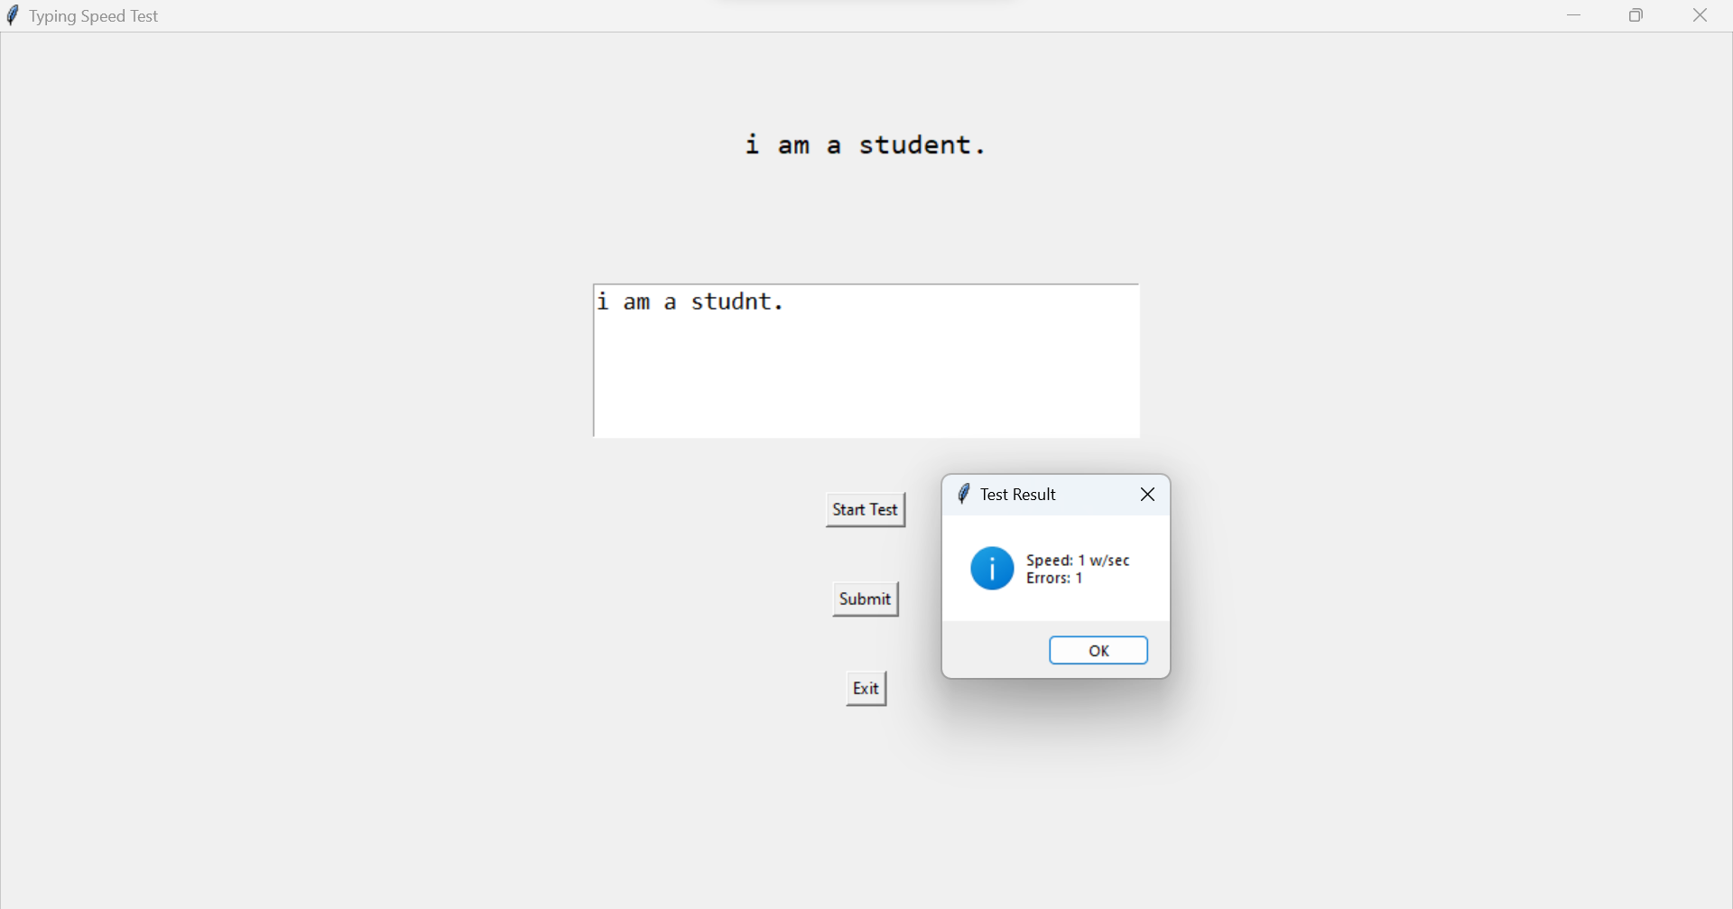

1. **Error Detection:**

* **Error Identification:** The program effectively identifies and categorizes errors in the input paragraph. It detects missing characters, incorrect capitalization, repeated words, missing spaces, and other common typing mistakes.
* **Real-time Feedback:** Users receive real-time feedback on errors, with visual cues highlighting the location and type of errors. This feature aids users in understanding and rectifying their typing mistakes.

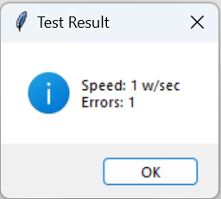

1. **User Interface:**

* **Intuitive Design:** The user interface is designed to be intuitive and user-friendly. Users can easily input paragraphs, receive instant feedback, and view calculated metrics.
* **Clear Presentation:** The results display presents typing speed and error count prominently, allowing users to assess their performance quickly. Additional details on specific errors are also provided.

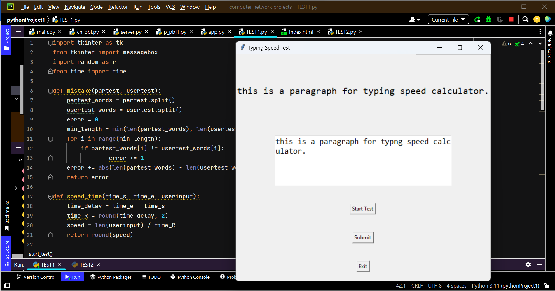

1. **Testing and Performance:**

* **Comprehensive Test Coverage:** Rigorous testing with a diverse set of test cases has been conducted, covering scenarios such as valid input, input with errors, special characters, mixed languages, and performance testing with large inputs.
* **Stability:** The program exhibits stability, with minimal resource usage and consistent performance across different operating systems and web browsers.
* A screenshot of a computer

  Description automatically generated

TEST CASES

**Designing test cases for a typing speed calculator program involves ensuring that the program accurately calculates typing speed and correctly identifies errors in a given paragraph. Here are some test cases we considered:**

**Test Case 1:** Valid Input

* **Input:** "This is a test paragraph."
* **Expected Output:**
* Typing speed: (calculated based on a predefined formula)
* Errors: 0

**Test Case 2:** Input with Errors

* **Input:** "Thss is a test paragrph."
* **Expected Output:**
* Typing speed: (calculated based on a predefined formula)
* Errors: 4 (characters 'i', 'i', 'a', 'a' are missing)

**Test Case 3:** Empty Input

* **Input:** ""
* **Expected Output:**
* Typing speed: 0
* Errors: 0

**Test Case 4:** Different Punctuation

* **Input:** "Hello! This is a test."
* **Expected Output:**
* Typing speed: (calculated based on a predefined formula)
* Errors: 0

**Test Case 5:** Mixed Case

* **Input:** "ThIs Is A MiXeD CaSe TeSt."
* **Expected Output:**
* Typing speed: (calculated based on a predefined formula)
* Errors: 0

**Test Case 6:** Numerical Input

* **Input:** "12345 67890"
* **Expected Output:**
* Typing speed: (calculated based on a predefined formula)
* Errors: 0

**Test Case 7:** Long Paragraph

* **Input:** (A long paragraph with a mix of words, punctuation, and numbers)
* **Expected Output:**
* Typing speed: (calculated based on a predefined formula)
* Errors: (number of errors in the paragraph)

**Test Case 8:** Special Characters

* **Input:** "@#$%^&*()_+"
* **Expected Output:**
* Typing speed: 0
* Errors: (number of characters in the input)

**Test Case 9:** Multiple Spaces

* **Input:** "This is a test."
* **Expected Output:**
* Typing speed: (calculated based on a predefined formula)
* Errors: 0

**Test Case 10:** Mixed Text

* **Input:** "This is a 123 test with @#$ characters."
* **Expected Output:**
* Typing speed: (calculated based on a predefined formula)
* Errors: 0

**Test Case 11:** Handling White Spaces

* **Input:** " This is a test. "
* **Expected Output:**
* Typing speed: (calculated based on a predefined formula)
* Errors: 0

**Test Case 12:** Case Sensitivity

* **Input:** "This Is A Test."
* **Expected Output:**
* Typing speed: (calculated based on a predefined formula)
* Errors: 0

**Test Case 13:** Non-English Characters

* **Input:** "Café au lait."
* **Expected Output:**
* Typing speed: (calculated based on a predefined formula)
* Errors: 0

**Test Case 14:** Mixed Language Input

* **Input:** "Bonjour! This is a test."
* **Expected Output:**
* Typing speed: (calculated based on a predefined formula)
* Errors: 0

**Test Case 15:** Performance Test

* **Input:** (A very long paragraph to test the program's performance)
* **Expected Output:**
* Typing speed: (calculated based on a predefined formula)
* Errors: (number of errors in the paragraph)

***These test cases cover a range of scenarios to ensure that the typing speed calculator program works correctly and handles various types of input. Adjust the expected outputs based on the specific requirements and implementation of your program.***

SNAPSHOT OF TEST CASE TEMPLATE OF TYPING SPEED CALCULATOR

ADVANTAGES AND DISADVANTAGES

**Advantages of a Typing Speed Calculator:**

1. **Skill Assessment:** The tool provides a quantitative measure of typing speed, allowing users to assess their proficiency and track improvements over time.
2. **Error Analysis:** By identifying and categorizing errors, users gain insights into specific areas for improvement, enhancing the overall quality of their typing.
3. **User-Friendly:** A well-designed Typing Speed Calculator offers a user-friendly interface, making it accessible to individuals of varying skill levels and age groups.
4. **Educational Value:** In educational settings, such a tool can be valuable for students and teachers alike, enabling educators to monitor progress and tailor lessons to address specific typing challenges.
5. **Professional Development:** Professionals who rely heavily on typing, such as writers, journalists, and data entry specialists, can use the calculator to refine their skills and increase productivity.
6. **Objective Evaluation:** Employers can leverage typing speed metrics as an objective measure during recruitment processes, particularly for roles where typing efficiency is crucial.
7. **Online Learning Platforms:** The calculator can integrate into online learning platforms, providing a practical and measurable aspect to typing courses and tutorials.

**Disadvantages and Challenges:**

1. **Subjectivity in Errors:** While the tool identifies errors, it may not capture nuances related to context, such as intentional deviations for creative writing or specific formatting requirements.
2. **Dependency on Input Quality:** The accuracy of the tool relies on the quality of input. Unconventional text, creative writing, or specialized content may not align perfectly with standard typing assessments.
3. **Not Applicable to All Professions:** Some professions may not benefit significantly from speed-focused typing assessments. Jobs that prioritize accuracy over speed may find limited value in such tools.
4. **Overemphasis on Speed:** Focusing solely on typing speed might overlook other essential skills, such as effective communication, critical thinking, and problem-solving abilities.
5. **Potential for Gaming the System:** Users might attempt to manipulate results by typing nonsensical text quickly, emphasizing speed at the expense of accuracy.
6. **Accessibility Concerns:** Users with certain disabilities or physical challenges may find typing speed assessments less relevant or even inaccessible.
7. **Technology Dependence:** The tool's effectiveness is contingent on the availability and reliability of technology, including hardware, software, and internet connectivity.

***In summary, while a Typing Speed Calculator offers numerous advantages in skill assessment and improvement, there are inherent challenges and limitations that need to be considered, particularly in diverse usage scenarios and user groups. The key is to balance the focus on speed with other essential aspects of effective communication and productivity.***

Top of Form

APPLICATION

The Typing Speed Calculator has a range of practical applications in various domains, contributing to individual development, educational settings, and professional environments. Here are some notable applications:

1. **Personal Skill Improvement:**

* **Self-Assessment:** Individuals can use the tool for self-assessment to track their typing speed progress and identify areas for improvement.
* **Skill Development:** It serves as a valuable aid for personal development, helping users enhance their typing proficiency over time.

2. **Education:**

* **Typing Courses:** Educational institutions can integrate the Typing Speed Calculator into typing courses, providing students with a practical and measurable aspect of their learning.
* **Monitoring Progress:** Teachers can use the tool to monitor students' typing progress and tailor lessons to address specific challenges.

3. **Professional Development:**

* **Professional Training:** Professionals in data entry, transcription, and content creation can utilize the tool for ongoing training and skill refinement.
* **Job Recruitment:** Employers can incorporate typing speed assessments during recruitment processes, especially for positions where typing efficiency is critical.

4. **Online Learning Platforms:**

* **E-Learning:** The Typing Speed Calculator can be integrated into online learning platforms, offering a practical dimension to typing courses and tutorials.
* **Certification Programs:** Online certification programs can use the tool to evaluate and certify participants' typing skills.

5. **Accessibility Tools:**

* **Assistive Technology:** The tool can be adapted for individuals with disabilities as part of assistive technology to support accessible learning and work environments.

6. **Content Creation and Editing:**

* **Writers and Journalists:** Professionals in writing and journalism can benefit from the tool to enhance their typing speed and efficiency during content creation.
* **Editing Support:** Editors can use the error analysis feature to identify and rectify typing errors in written content.

7. **Data Entry and Transcription Services:**

* **Data Entry Professionals:** Individuals working in data entry roles can use the Typing Speed Calculator to maintain and improve their typing efficiency.
* Transcriptionists: Transcription services can leverage the tool for ongoing skill development and quality assurance.

8. **Digital Literacy Initiatives:**

* **Digital Literacy Programs:** The tool can be incorporated into digital literacy programs to teach individuals foundational typing skills essential for effective digital communication.

9. **Gaming and Entertainment:**

* **Typing Games:** The Typing Speed Calculator concept can be gamified, creating entertaining and educational typing games that engage users in improving their skills.

10. **Remote Work and Telecommuting:**

* **Remote Collaboration:** As remote work becomes more prevalent, individuals can use the tool to maintain and enhance their typing speed for efficient communication.

11. **Language Learning Platforms:**

* **Language Learners:** Language learning platforms can integrate typing exercises and assessments to enhance learners' language proficiency and typing skills.

***The applications of a Typing Speed Calculator extend across diverse settings, emphasizing its role in fostering individual development, supporting education, and contributing to professional success in an increasingly digital world.***

CONCLUSION

**The report concludes with insights gained from the design, implementation, and testing phases. The Typing Speed Calculator program demonstrates proficiency in accurately measuring typing speed while providing meaningful feedback on errors. The thorough testing process ensures the reliability and versatility of the program, positioning it as a valuable asset for users aiming to enhance their typing capabilities.**

**While the Typing Speed Calculator places a focus on speed, it is important to note its broader significance. The program contributes to digital literacy, effective communication, and personal development. The nuanced error analysis encourages users to not only type quickly but also accurately, emphasizing the importance of precision in written communication.**

**In an era where digital communication is integral to daily life, the Typing Speed Calculator stands as a relevant and valuable tool. Its impact spans across educational, professional, and personal spheres, aligning with the ever-increasing demand for efficient and accurate typing skills. The journey from conceptualization to implementation has been marked by meticulous attention to detail, a commitment to user-centric design, and a vision for the program's role in fostering digital proficiency.**

**In essence, the Typing Speed Calculator program represents more than just a technical solution; it embodies the intersection of technology and a fundamental skill that transcends industries and empowers individuals in their digital endeavors.**